**Gimme a Kiss!**

**Hershey’s Kisses and Confidence Intervals**



In this activity, we will estimate a confidence interval for the proportion of times a Hershey’s kiss lands on its base as opposed to its side. To do this, we will drop Hershey’s kisses, count how many land on their base, and calculate the confidence interval.

To take your sample, gather five Hershey’s kisses in your cup, shake them up, and drop them from about six inches above your desk. Count the number that land on their base.

Repeat ten times to get a sample of size 50, recording your results in the table below.

|  |  |  |  |  |
| --- | --- | --- | --- | --- |
| Toss Number | Number that land on base |  | Toss Number | Number that land on base |
| 1 |  |  | 6 |  |
| 2 |  |  | 7 |  |
| 3 |  |  | 8 |  |
| 4 |  |  | 9 |  |
| 5 |  |  | 10 |  |
|  |  |  |  |  |
| **Total** |  |  |  |  |

What is the population of interest? _______________________________

What is the sample? ______________________________________

Your result (50 tosses combined): $\hat{p}$ =

The results of the others in your group: ________ ________ ________

Compare your $\hat{p}$ with the others in your group. Did you all get the same answer? ________

Follow these steps to make a 95% confidence interval based on your result.

• Calculate the standard deviation of your sample proportion (standard error):

$$σ_{\hat{p}}=\sqrt{\frac{\hat{p}(1-\hat{p})}{50}}$$

• Look up the critical value, z*, that corresponds to 95% confidence. Note, this is the z-score that corresponds to the middle 95% of the normal distribution. (Hint: what percentage would be left in each tail of the distribution? Use this & invNorm OR use this & the ∞ row of the t-table to find the z-score). The positive z-score is the critical value.

z*95% = ___________

• The confidence interval is $\hat{p}±\left(z_{95\%}^{*}×σ_{\hat{p}}\right)$ where **the critical value multiplied by the standard error is the margin of error** for the interval. Adding and subtracting the margin of error from the sample statistic creates the lower and upper bounds for the confidence interval.

your lower bound = ___________ your upper bound = ____________

Use the lines below to roughly draw the confidence intervals of each person in your group. Indicate the location of $\hat{p}$ as a dot. (An example of a CI from 0.13 to 0.37 with $\hat{p}$ = .25 is given.)

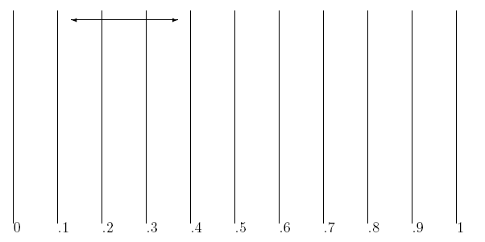

)

(

After comparing with your group, plot your dot sticker on your $\hat{p}$-value on the chart at the front of the room. Using a marker extend a line from your dot to your lower bound and upper bound (in similar fashion as the diagram above)

Interpret the 95% confidence interval in your own words. Write your interpretation below.

Compare your interpretation with your group members’ interpretations and come to an agreement on an appropriate interpretation. Write it below.

If you’ve completed these tasks and questions, eat a Hershey’s Kiss while you ponder the following: Which of the following do you think is true (more than one may be true)?

1. There is a 95% probability that the true proportion will fall in your interval.
2. There is a 95% probability that your interval will include the true proportion.
3. BEFORE we take the sample, there is a 95% probability that the confidence interval we will create WILL include the true proportion.
4. AFTER we take the sample, there is a 95% probability that the confidence interval we created DOES include the true proportion.